DON BOSCO INSTITUTE OF TECHNOLOGY KURLA, MUMBAI

A PROJECT REPORT ON

**“To-do List ”**



**Submitted By:** Viola Noronha ( 42)

Floria Pinto (45)

**Under The Guidance of:**

**[ Prof. Prasad Padalkar ]**

**DEPARTMENT OF INFORMATION TECHNOLOGY**

**(2021-2022)**

# CERTIFICATE

This is to certify that the project entitled **“ [ To-do List ] ”** is a bonafide work of **Viola Noronha and Floria Pinto** submitted to the University of Mumbai in partial fulfillment of the requirement for the award of the degree of “**SE** **IT”** in **“Java Mini Project ”**.

(GUIDE SIGNATURE) (HOD ) SIGNATURE)

# Approval Certificate

This project report entitled website on [ ] by Viola Noronha, and Floria Pinto is approved for the degree of Bachelor of Engineering in Information Technology.

Examiners

1.---------------------------------------------

Name:-

Date:-

Place:-

# Declaration

I declare that this written submission represents my ideas in my own words and where others' ideas or words have been included, I have adequately cited and referenced the original sources. I also declare that I have adhered to all principles of academic honesty and integrity and have not misrepresented or fabricated or falsified any idea/data/fact/source in my submission. I understand that any violation of the above will be cause for disciplinary action by the Institute and can also evoke penal action from the sources which have thus not been properly cited or from whom proper permission has not been taken when needed.

--------------------------------------

( Viola Noronha - 42

Floria Pinto – 45 )

Date:

Abstract

The reason we chose this topic was to make people understand the importance of being punctual and to understand time management. This also makes us realize how important it is to do our daily tasks on time. We had planned on adding the following features:

Like adding tasks , showing the pending tasks , an in built calendar and adding categories.

We’ve managed to implement all the features mentioned above. The most difficult part was to display task accordingly with selected category.

# Table of Contents

Chapter 1: Introduction

Chapter 2: Review of Literature

Chapter 3: Analysis and Design

Chapter 4: Implementation

Chapter 5: Results and Discussion

Chapter 6 : Conclusion

1.1 Problem Statement

To design a To-do List manager that makes one aware of how they spend time in the process of doing tasks and help them become productive. It tracks their activity to make them more efficient.

1.2 Scope of the Project

1)Task reminders - Have your device remind you every few minutes to ensure you get the message.

2) Time tracking - Keep track of both estimated and actual length of tasks.

3) Calendar Integration - You can view your tasks on your device’s calendar, allowing you to see both calendar events and to-do items on one screen.

4) Simple UI - Simple to use. Simple user interface. Too many features just clutter things up.

5) Quick and Easy to use - Creates tasks fast and easily.

6) Prioritization - It is important to be able to separate important tasks from the lesser ones.

1.3 Current Scenario

Login , sign up page , database being connected , working home page and profile page with the required features.

1.4 Need for the Proposed System

It helps in managing time and then doing the tasks on time i.e time management.

# Chapter 2 : Review of Literature

2.1 Summary of the investigation in the published papers/websites / existing applications

Our app offers inserting tasks on the date you want and then allows to set categories. There’s an add task option that helps you to add the tasks accordingly. Our app offers you an in built calendar too. Our app displays the remaining amount of tasks as well. This also helps in time management and helps you to be disciplined too. Our app has limited features but it fulfils all the required requirements. You can also add a new category in our app.

# Chapter 3 : Analysis and Design

3.1 Methodology/Analysis Circuit diagram of hardware and explanation

3.2 System architecture /Design

ER DIAGRAM

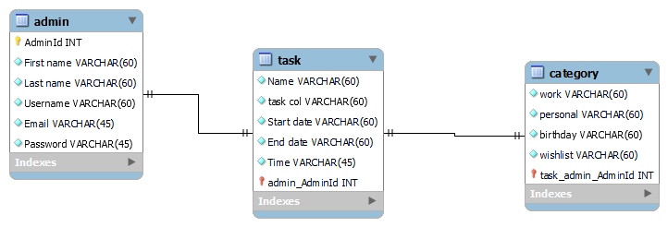

SQL COMMANDS

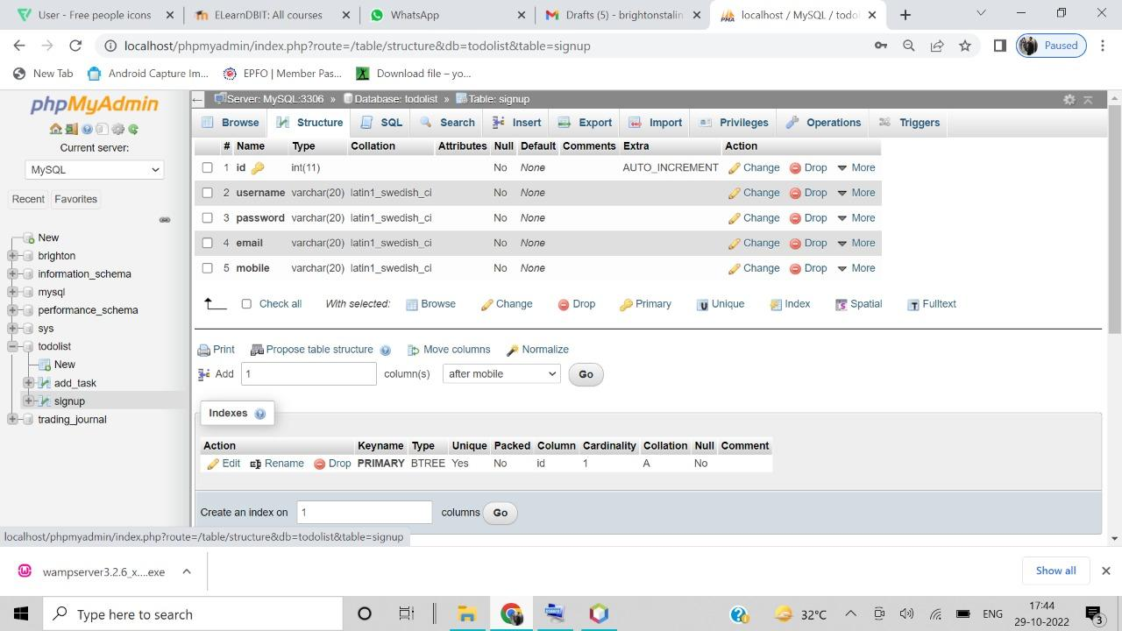

SQL COMMANDS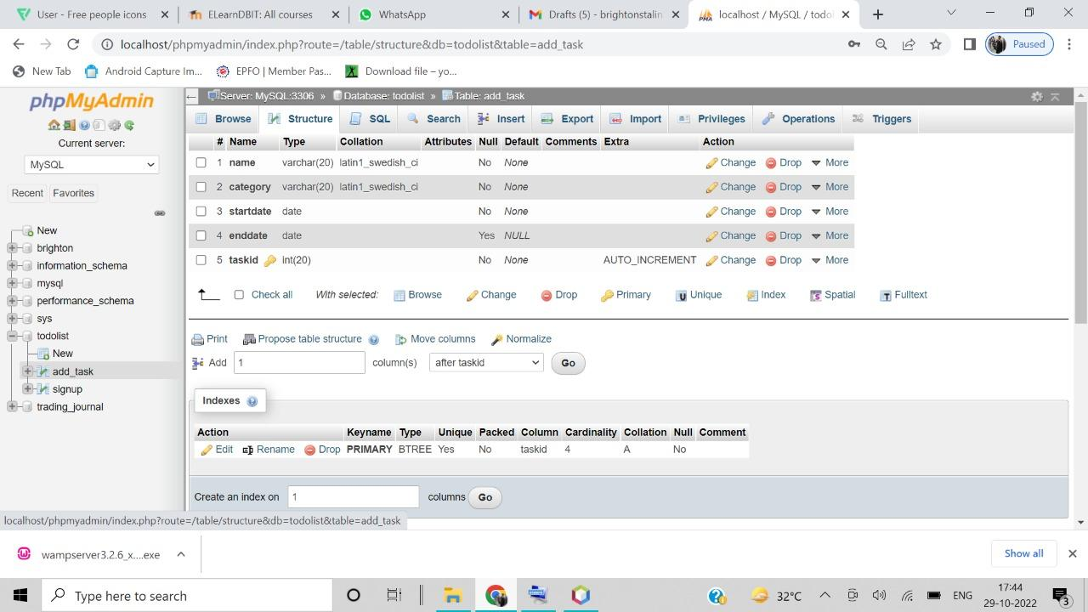

SQL COMMANDS 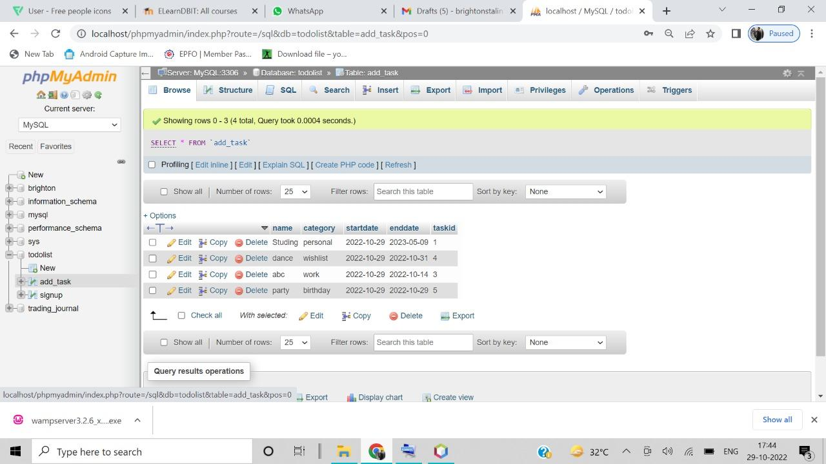

SQL COMMANDS

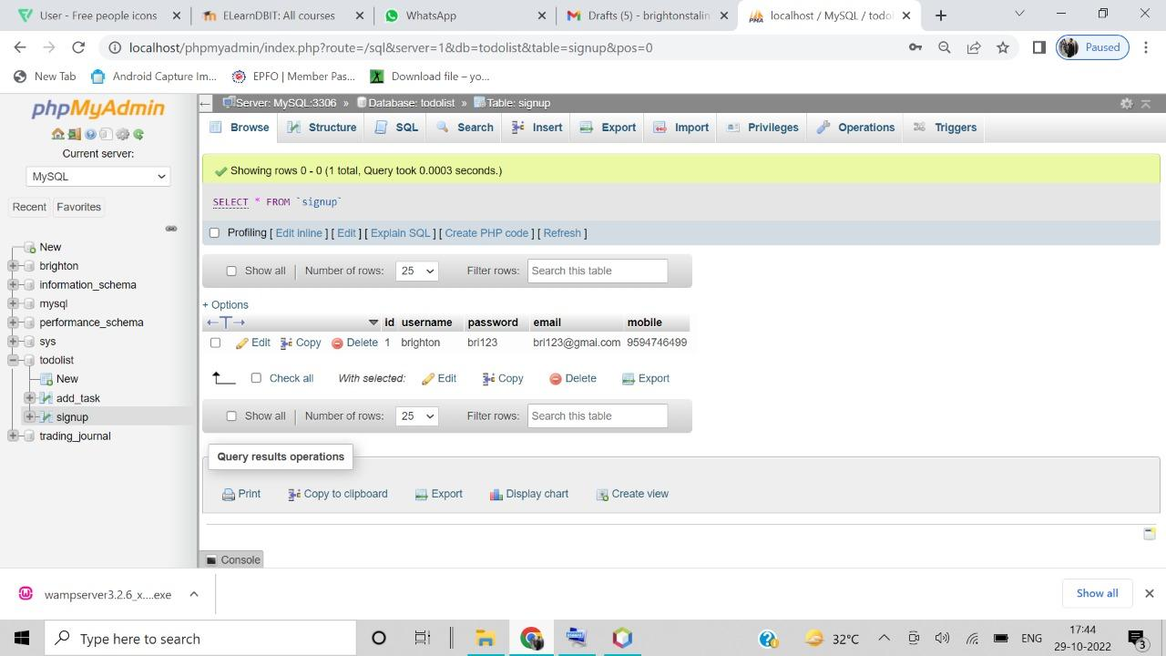

# Chapter 4 : Implementation

**Screenshots and working shall be explained step by step of your applications in the chapter**

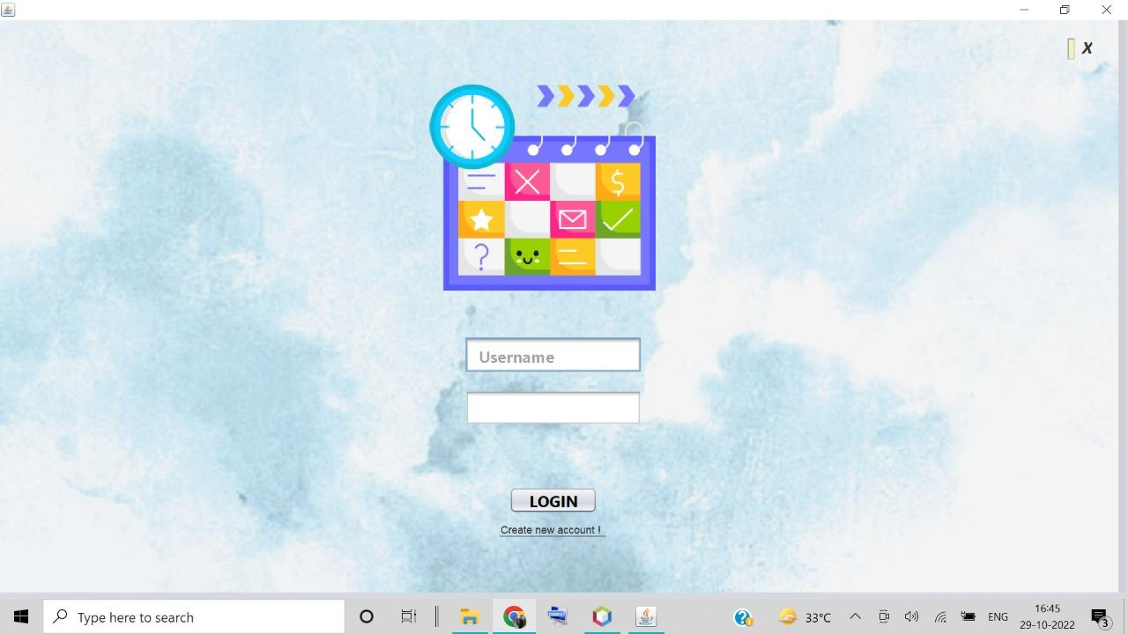

1. LOGIN PAGE

This page asks you to input your previous existing account details.

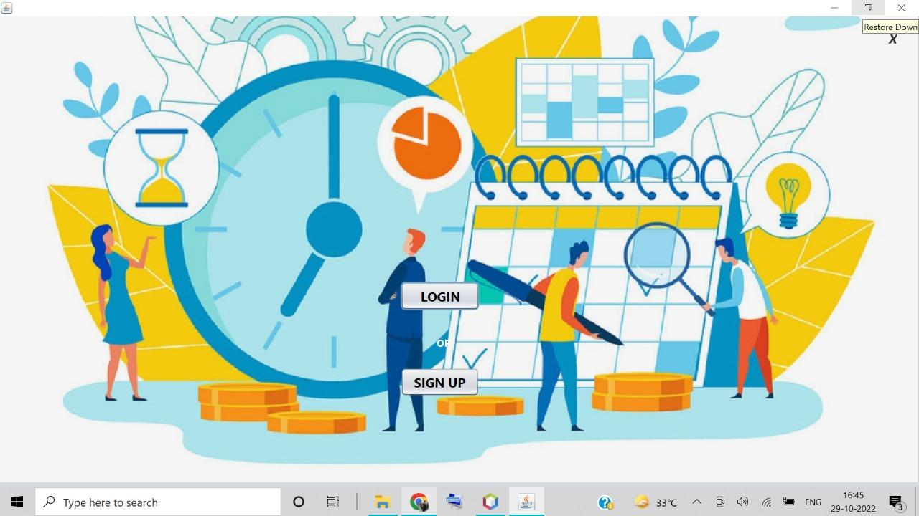

1. START PAGE

You can either login or you can sign up if you are a new user.

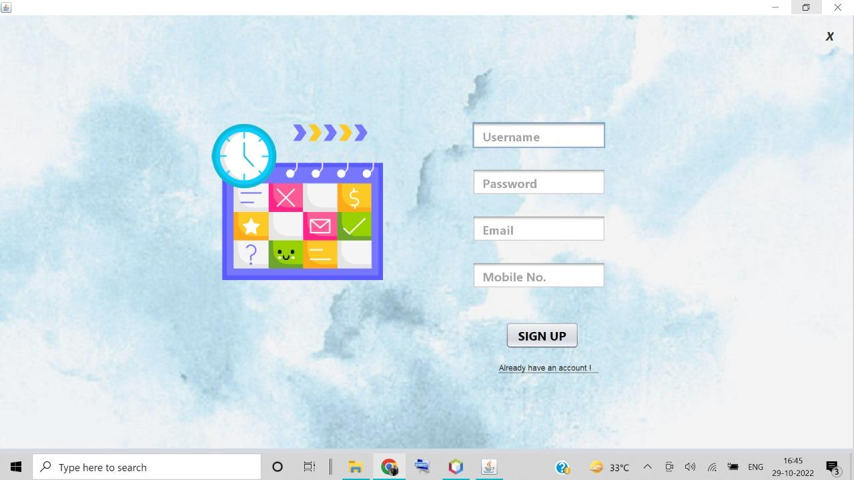

1. SIGN UP PAGE

This is the sign up page. Here you will have to create a username, password, email and your mobile number and then after signing up you will get your account created.

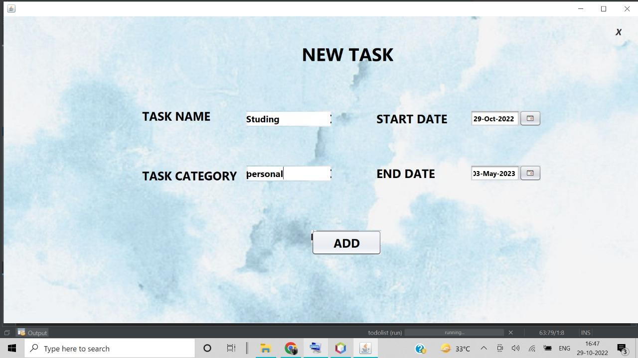

1. NEW TASK PAGE

This is the page where you add a new task according to your category. You’ll also have to insert start date and end date.

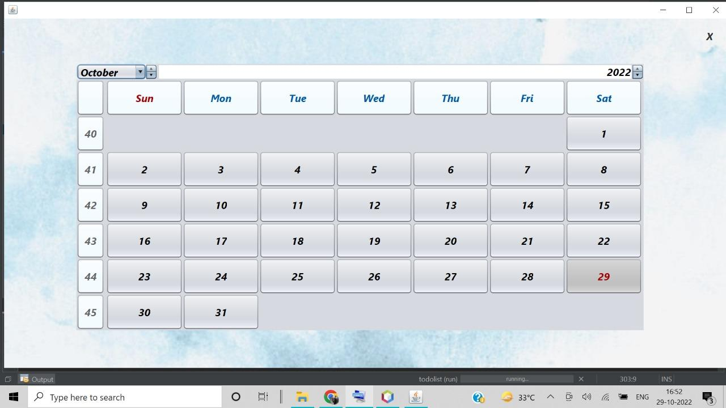

1. CALENDAR PAGE

This is the calendar page where the calendar is displayed.

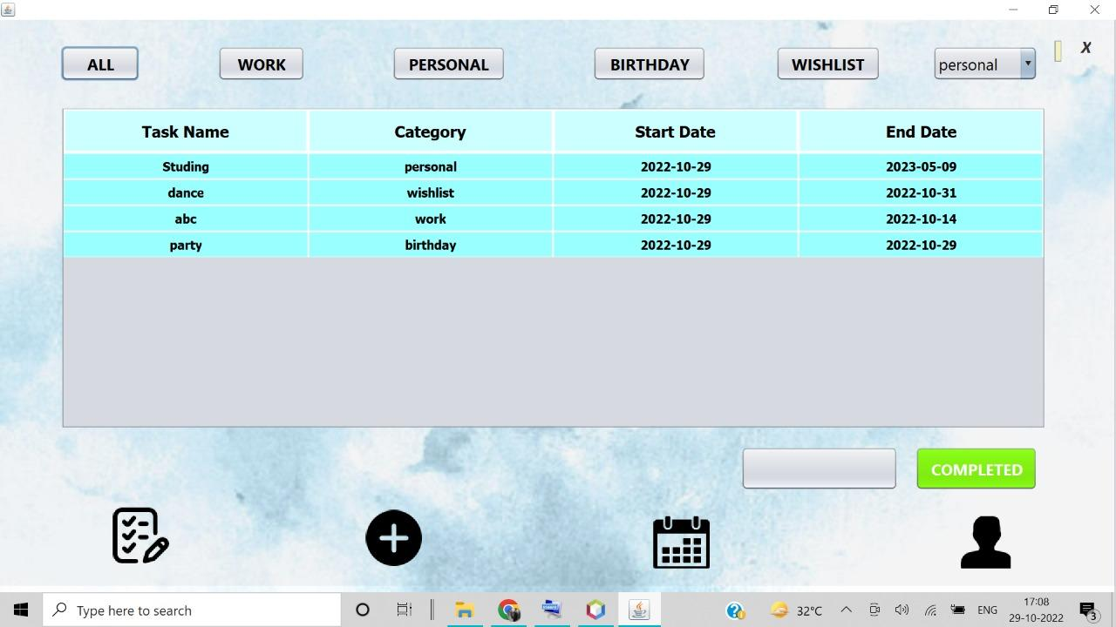

1. MAIN PAGE

This page will display all your tasks with it’s category along with the start and end date.

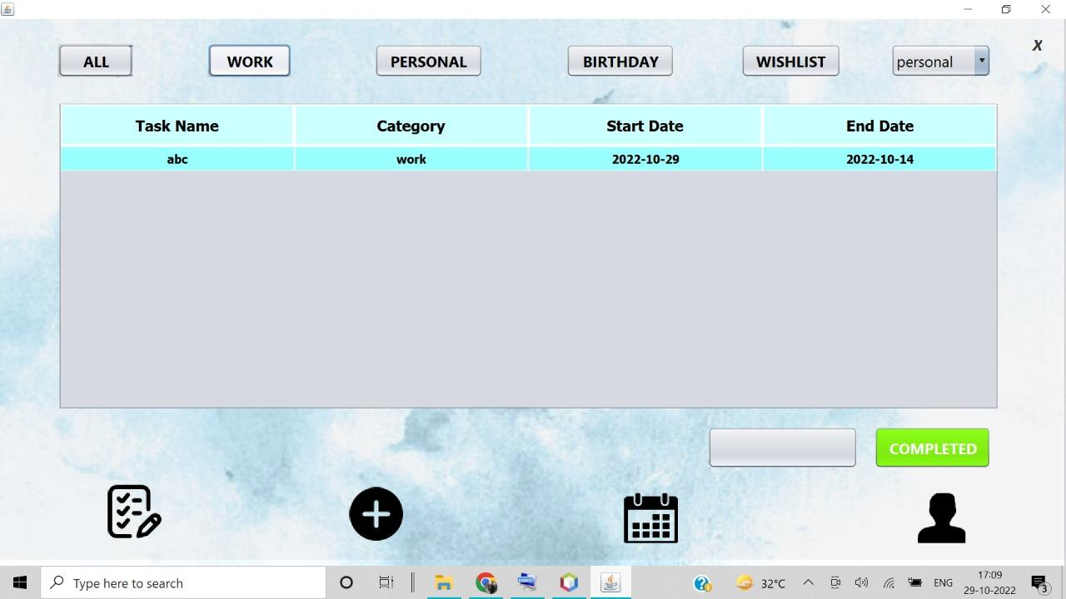

1. MAIN PAGE

This page deletes the task once you’ve hit the complete button.

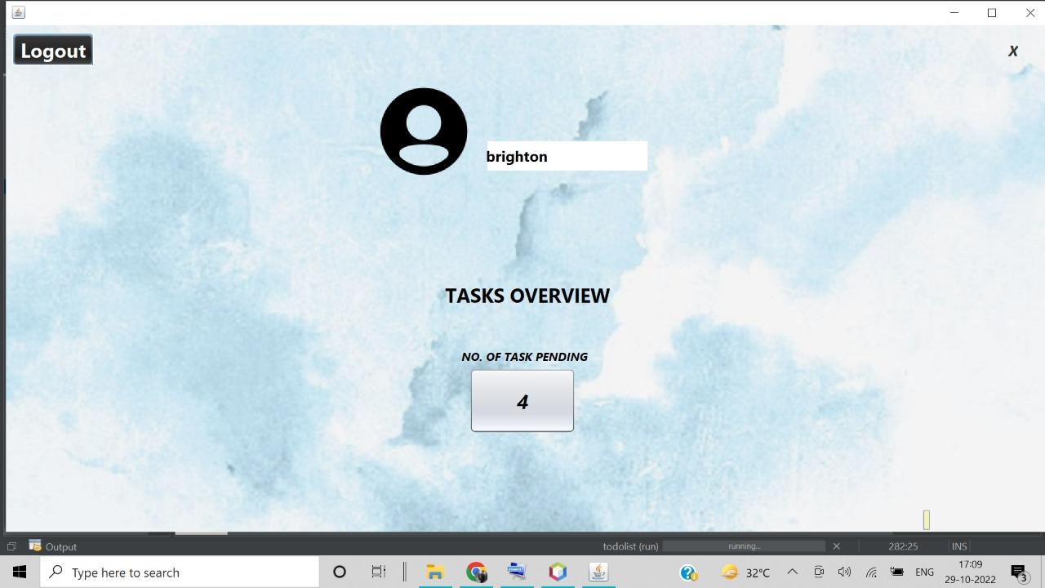

1. PROFILE PAGE

This page shows the number of tasks pending with the username and this also has the log out option from where you can log out.

# Chapter 5 : Results and Discussion

Even though the app has limited features it does what it’s supposed to do. After installing the app you can either login if you have an existing account or you can sign up if you are starting anew. You can also add tasks according to your needs and hit the completed button once done. It will also display the pending tasks on the screen. This app will help you keep a track of all your tasks and also helps in time management.

# Chapter 6: Conclusion

Lessons learned

While working on this app it taught us java in a way better manner. We also learned how to work in teams and adjust according to everybody’s needs. It also taught us how respect each others opinions and ideas. This was a wonderful experience.

# References

[1]. [Learn Java in 14 Minutes (seriously) - YouTube](https://www.youtube.com/watch?v=RRubcjpTkks)

[2]. [05. ToDo List in JAVA Netbeans - YouTube](https://www.youtube.com/watch?v=X5VkkBuR0SA)

**GITHUB LINKS**

[violanoronha/Mini-Project--To-do-list (github.com)](https://github.com/violanoronha/Mini-Project--To-do-list)

[floria-pinto/Mini-Project-To-do-list (github.com)](https://github.com/floria-pinto/Mini-Project-To-do-list)